OUM for Business Flows

DO070 USER Manual

NWC Company

Oracle Procurement Contract

**Author:** Tarek Nassar

**Creation Date:** Apr - 20 - 2022

**Last Updated:** Apr - 20 - 2022

**Document Ref**:  NWC DO.070 V1.0

**Version:** V 1.2

1. **Title, Subject, Last Updated Date, Reference Number**, **and** **Version** are marked by a Word Bookmark so that they can be easily reproduced in the header and footer of documents. When you change any of these values, be careful not to accidentally delete the bookmark. **You can make bookmarks visible by selecting Tools->Options…View and checking the Bookmarks option in the Show region.**

# Document Control

## Change Record

| Date | Author | Version | Change Reference |
| --- | --- | --- | --- |
| 20 Apr 2022  19 May 2022 | Tarek Nassar  Wayne Steel | V1.0  V1.2 |  |

## Reviewers

| Name | Position |
| --- | --- |
| Tarek Nassar | Oracle SCM consultant |
| Mohammed Toney | Project Manager |
|  |  |
|  |  |

## Distribution

1. The copy numbers referenced above should be written into the **Copy Number** space on the cover of each distributed copy. If the document is not controlled, you can delete this table, the Note To Holders, and the **Copy Number** label from the cover page.

| Copy No. | Name | Location |
| --- | --- | --- |
| 1. 1 |  | Riyadh, KSA |
|  |  |  |

**Note To Holders:**

If you receive an electronic copy of this document and print it out, please write your name on the equivalent of the cover page, for document control purposes.

If you receive a hard copy of this document, please write your name on the front cover, for document control purposes.

Contents

Document Control 2

Change Record 2

Reviewers 2

Distribution 2

Preface 4

How This Manual Is Organized 4

Your Comments are Welcome 4

Adding new contact to be the authorized person…………………………………………………………………………………

Award recommendation letter page **……………………………………………………………………………..**

Supplier aknowledge page 20

Open and Closed Issues 22

Open Issues 22

Closed Issues 22

# Preface

1. Provide a brief introductory sentence for the Preface.
2. If you change the main headings for this Preface, then be sure to update the bullet list below.
3. To update the cross-references in the bullet list:  
     
   1. Choose Insert > Cross-Reference.  
     
   2. Select the correct heading, and click OK.

This user guide introduces you to **Oracle Contract Procurement** and teaches you to use it to perform Oracle Contract Procurement functions.

# How This Manual Is Organized

This guide contains the following chapters:

Suppliers acknowledge for Contract

### Your Comments are Welcome

**Evosys** values and appreciates your comments as a user and reader of this manual. As we write, revise, and evaluate our documentation, your comments are the most valuable input we receive. If you would like to contact us regarding comments and suggestions on future releases of Oracle Procurement Contract, please use the following contacts:

Emails< tarek.nassar@evosysglobal.com>

## Adding the authorized person as a new contact

**To successfully select the authorized person, the supplier should ensure the following:**

**-Contact should have Username,**

**-Contact should be approved,**

**-Contact should have Authorized person flag equal to “Yes”,**

**-Contact should not be expired.**

**-Contact should have Username,**

**Go to the contact page and then make sure that contact have Username as follows:**

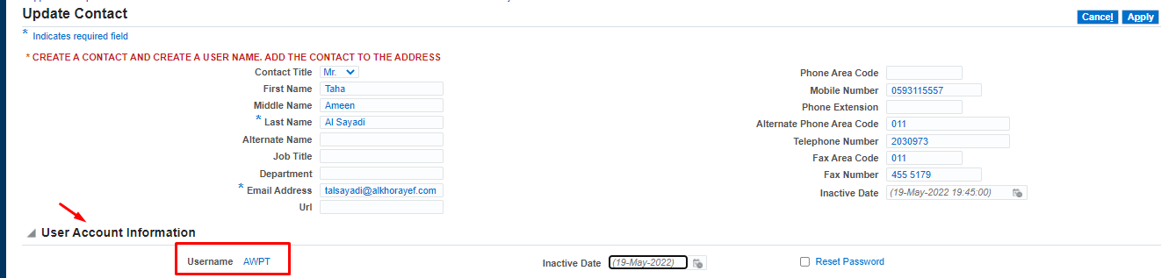

- **Contact should have Authorized person flag equal “Yes”,**

**Go to the contact page and make sure that contact authorized person flag equal "Yes" as below:**

1. **Click on " Contact Descriptive Flexfield**

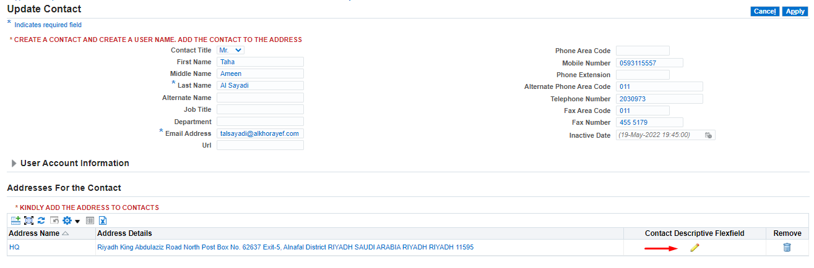

**Then Choose Yes as follows:**



**Click Apply to save,**

**-Contact should not be expired**

**Go to the contact page and make sure that there is no inactive date as follows:**

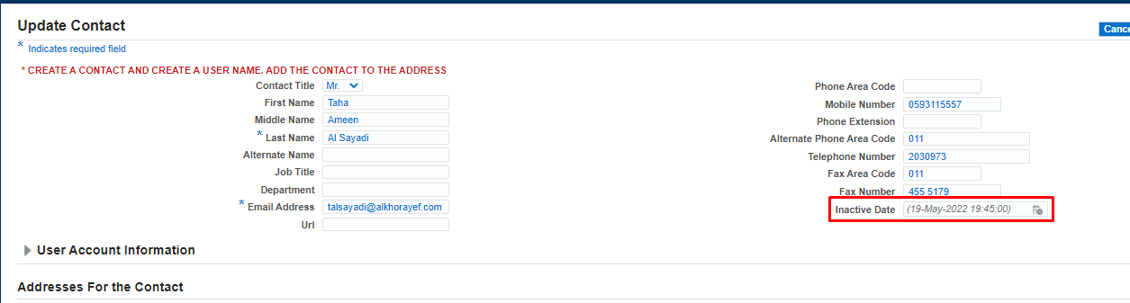

**Once the authorized person has been successfully added, they can be selected in the “award recommendation letter page"**

## Award Recommendation letter page

**On this page, the supplier will use the same previous features with the added new feature to now choose / add his Authorized person and position and upload their signature to reflect automatically on the contract.**

**Supplier logs in to the system with his username:**

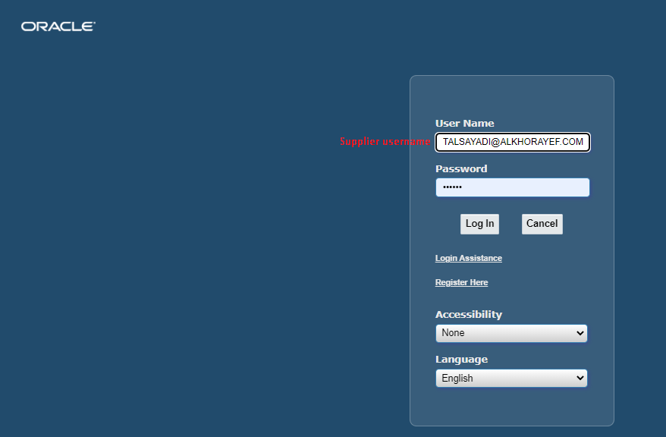

**When executing " NWC Award Recommendation Letter - Send to Vendor " request,   
Supplier will receive a notification as below:**

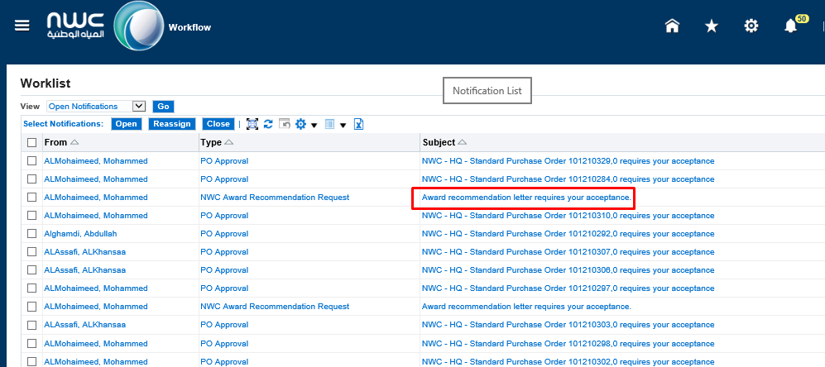

**After opening the notification, the below screen will display:**

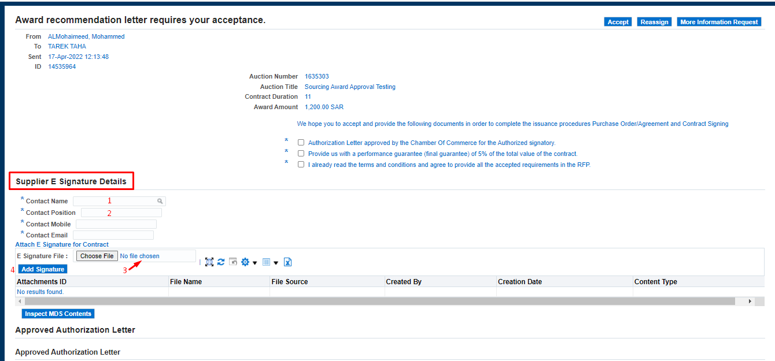

**To successfully select the authorized person, the supplier should consider the following:**

**-Contact should have Username,**

**-Contact should be approved,**

**-Contact should have Authorized person flag equal to “Yes”,**

**-Contact should not be expired.**

**Then**

1. **Supplier will choose the Authorized person,**
2. **Supplier will choose the Authorized person's position,**
3. **Supplier will choose the Authorized person's signature,**
4. **Supplier will click on Add the signature (Signature must be "PNG-GIF-JPG" format).**

**Following the above, the supplier can proceed normally on the page to add:**

**-Approved authorization letter**

**-Bank Guarantee letter**

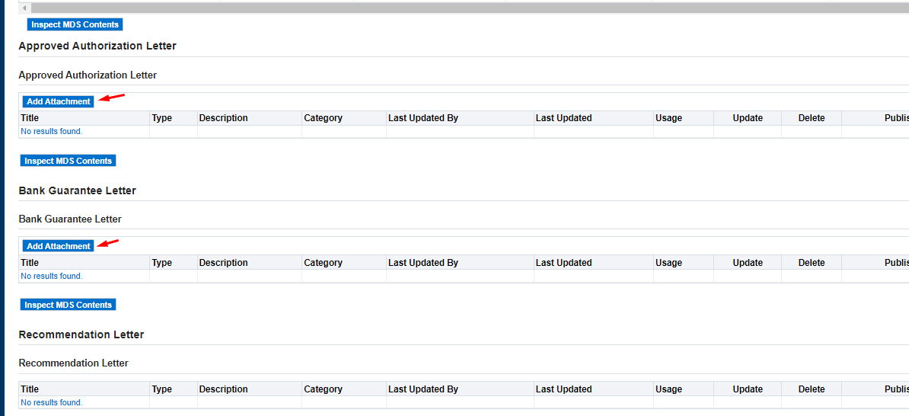

**After entering all information,**

**Click Accept.**

**-In case we open the notification and found the below RED Note:**

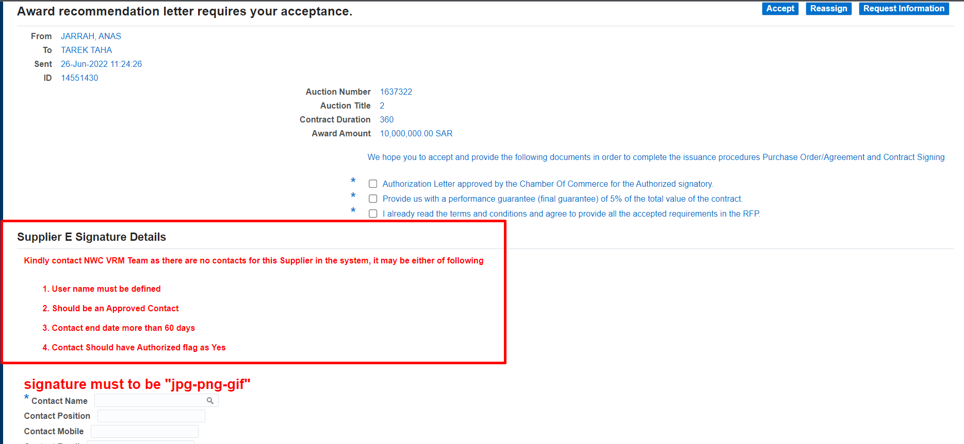

**This mean that there is no authorized person is defined yet or the 4 conditions didn’t achieve to find him,**

**So you have to fulfill all the points to find the authorized person in the drop list.**

## Supplier Acknowledge Page

**Once The PO is approved, the supplier username will get a notification for acceptance as below:**

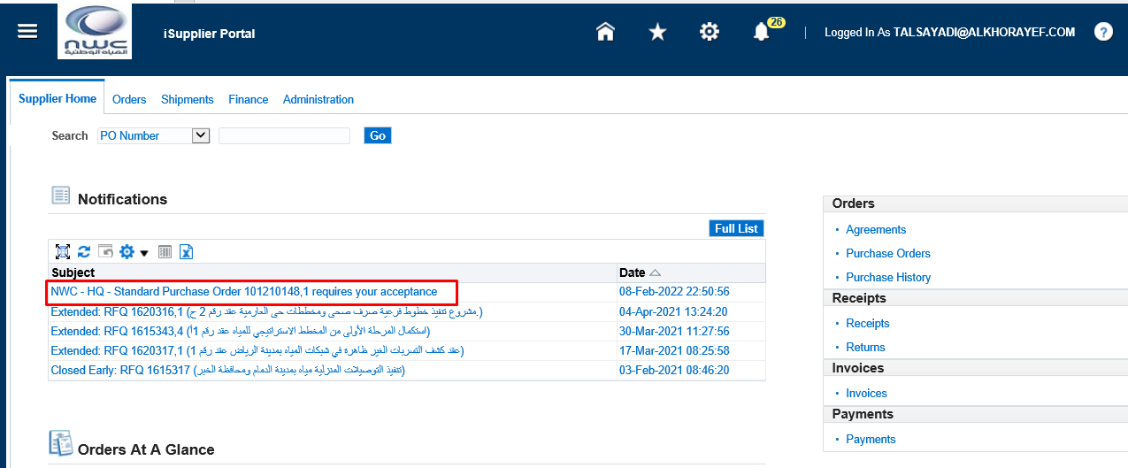

**Upon opening the notification, the screen below will appear:**

**The Supplier can check the Contract by clicking on "** XXNWC PDF Document " "1"

**To check the attachments of the PO click on** " Zip Attachment " "2"

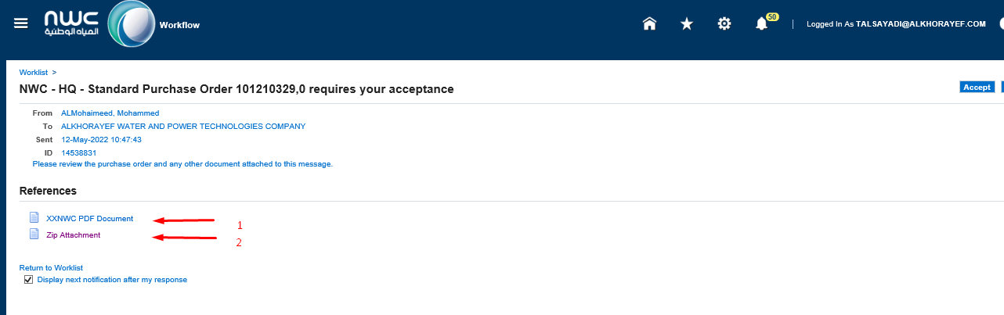

**After reviewing and checking the Contract, the authorized person can accept the contract by selecting:**

* **Accept**

**Once supplier click on Accept, system will send a notification to the buyer of the supplier acknowledgment,**

## Open and Closed Issues

### Open Issues

| ID | Issue | Resolution | Responsibility | Target Date | Impact Date |
| --- | --- | --- | --- | --- | --- |
|  |  |  |  |  |  |
|  |  |  |  |  |  |
|  |  |  |  |  |  |
|  |  |  |  |  |  |
|  |  |  |  |  |  |

### Closed Issues

| ID | Issue | Resolution | Responsibility | Target Date | Impact Date |
| --- | --- | --- | --- | --- | --- |
|  |  |  |  |  |  |
|  |  |  |  |  |  |
|  |  |  |  |  |  |
|  |  |  |  |  |  |
|  |  |  |  |  |  |